1. 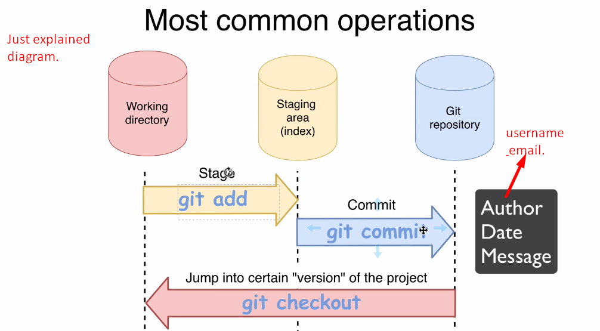
2. **git checkout**:
   1. This command retrieves the files/folders from a specific version in git repository and put those into working directory and also in staging area (index)
3. Let’s explain the following diagram to see how different file states relate to different git areas (Working Area, Staging Area, Git Repo).  
   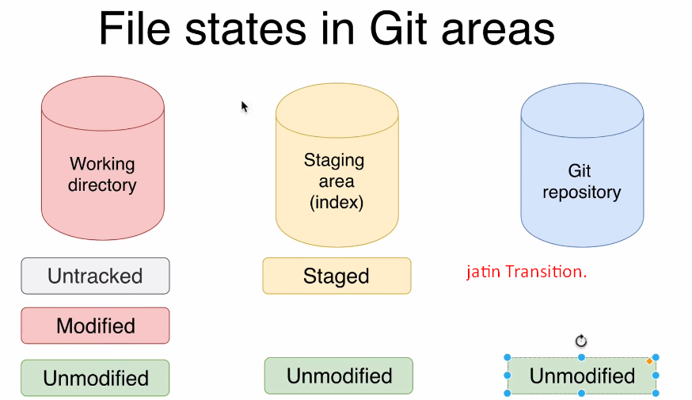
   1. **Untracked files**: Resides only in working dir and missing from staging area and git repo.
      1. **Untracked file**: Creating a new file into working.
      2. **Staged**: “git add” would add the file to staging area and it would remove from the section “untracked files”.
      3. **Unmodified**: “git commit” would
         1. Write the file into git repo.
         2. Change the status of the file to “Unmodified” under “Working Dir”, “Staging Area”, “Git Repo”.
   2. **Modified**:
      1. **Modified**: When a working dir file is synchronized with staging area and you modify it, it goes to the status “**modified**”.
      2. **Staged**: “git add” would add the file to the staging area and changes the status to “**Staged**”
      3. **Unmodified**: “git commit” changes the file’s status to “**unmodified**”.
4. 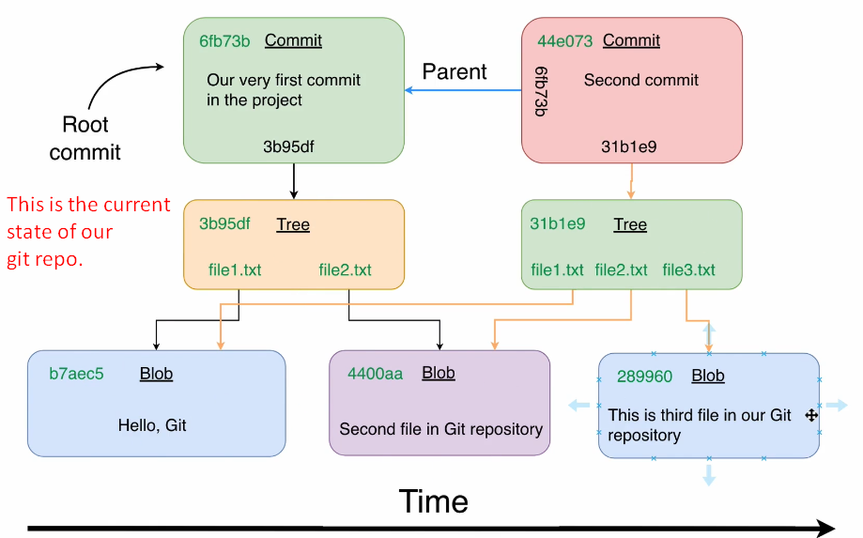
5. **Next Lec**: Checkout command.